Done in Microsoft fabric notebook
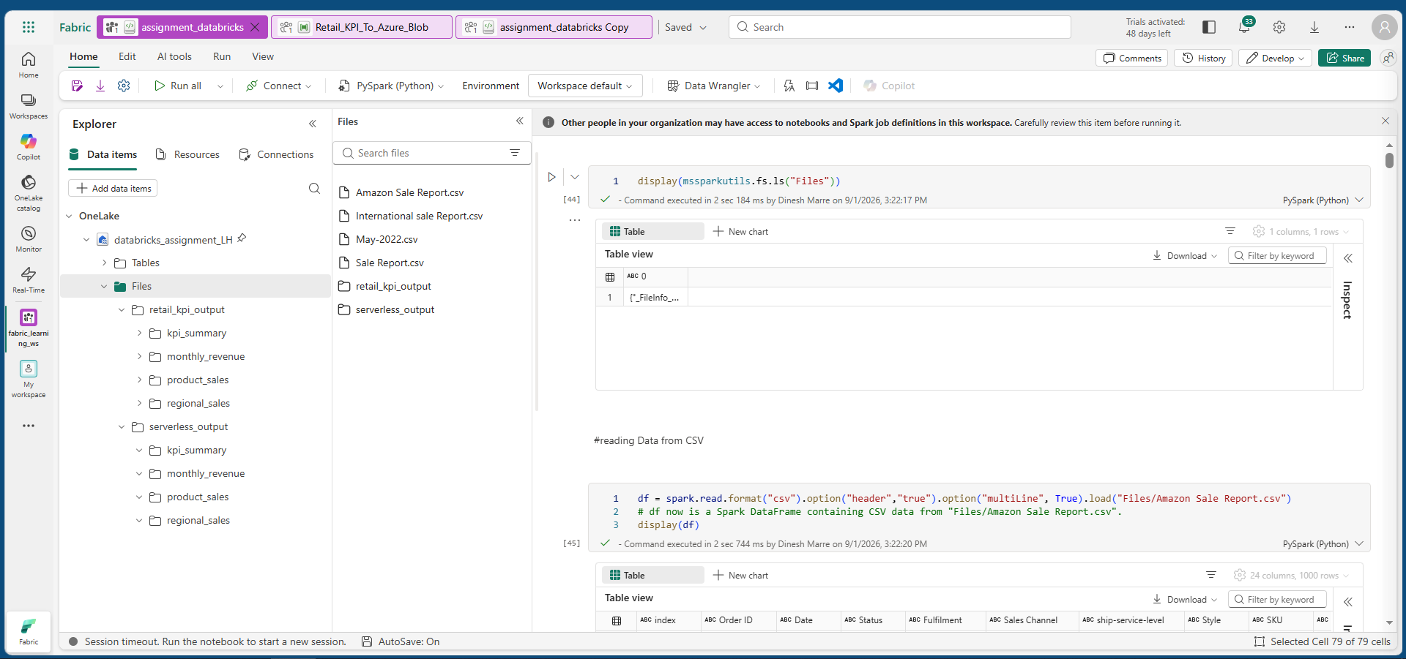
Configured pipeline to fabric from azure blob to save output parquet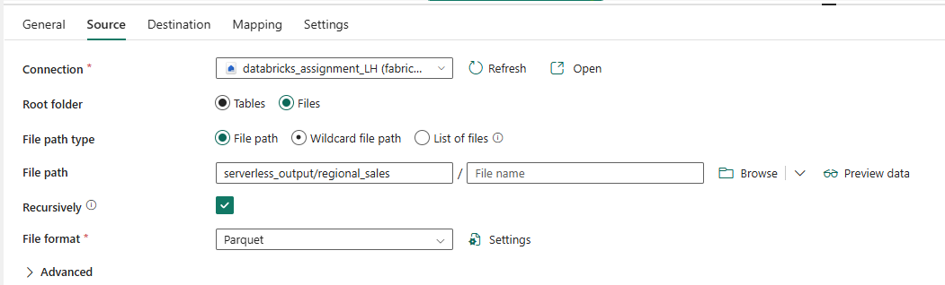
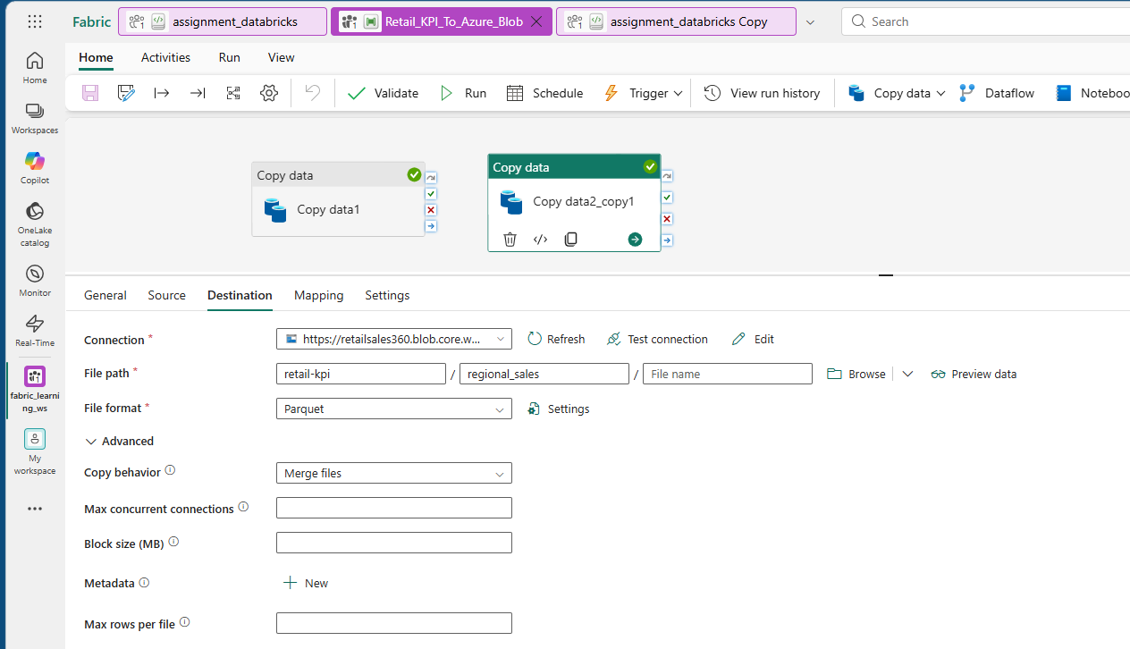

Azure Blob storage container for output parquet
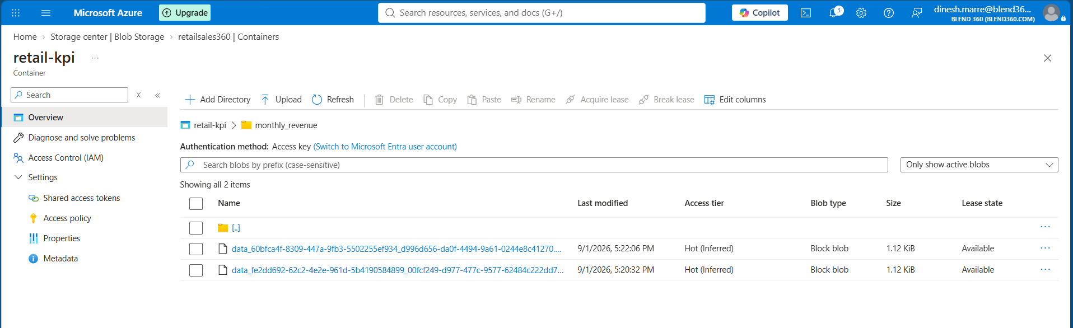
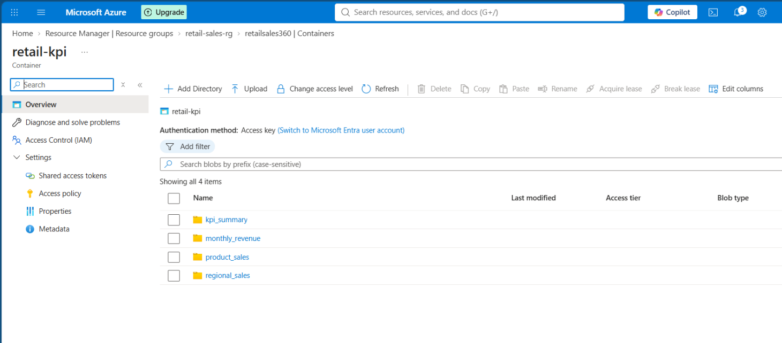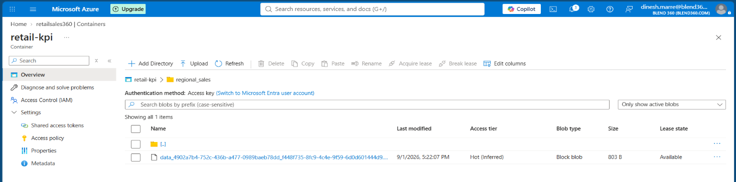
Azure app function couldn’t able to go with free tier: Created and deployed through console
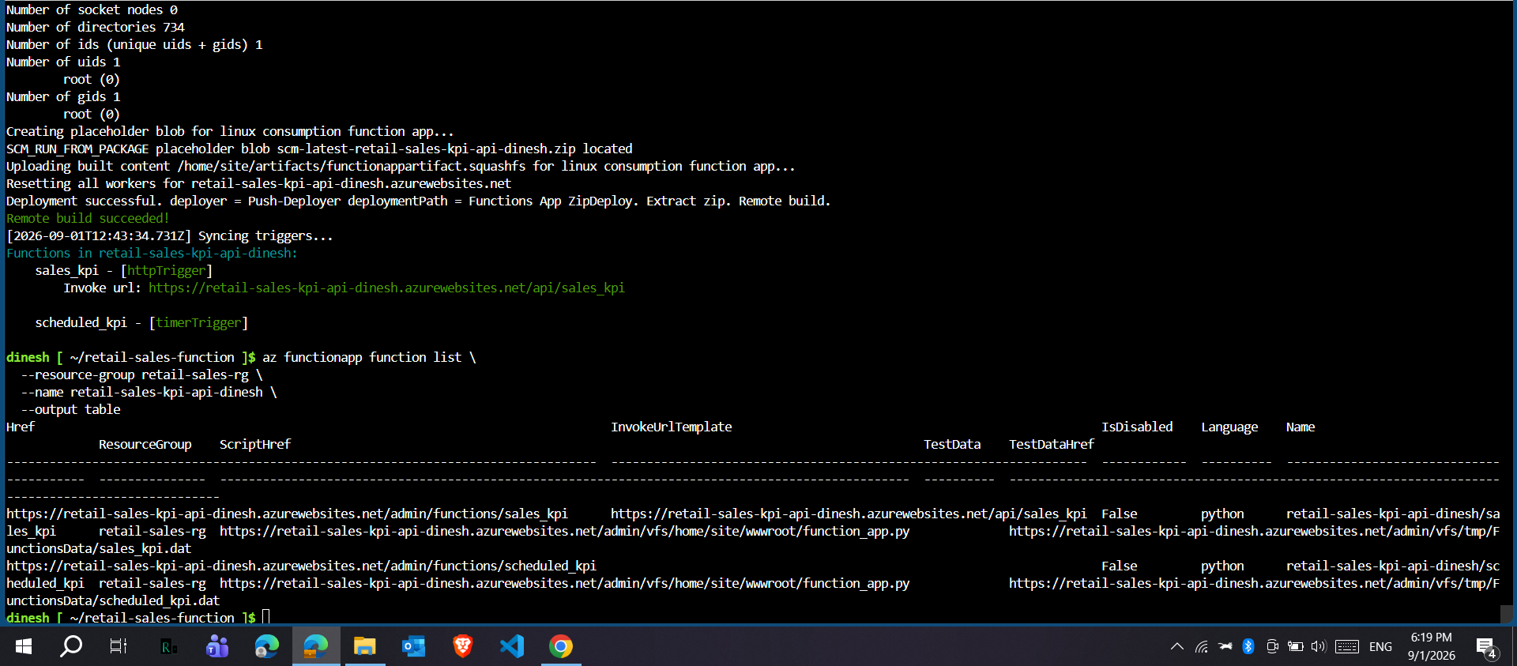
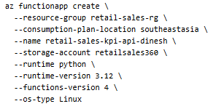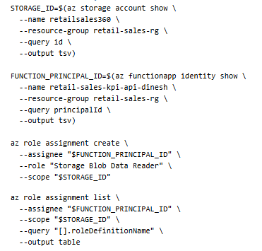
API URL:
https://retail-sales-kpi-api-dinesh.azurewebsites.net/api/sales_kpi
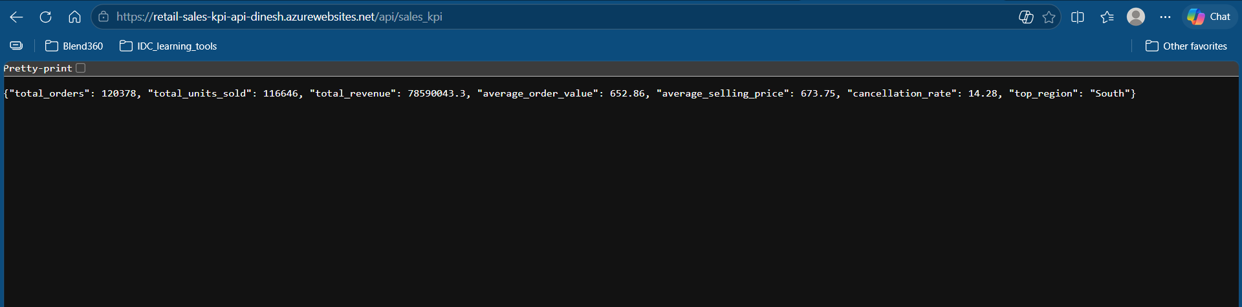
Scheduling to run once a week